

**P.E. and Swimming**

P.E. will take place on Wednesday afternoons. Please provide named PE guddies for your child which will stay in school. On PE day please send your child to school in their PE kit which consists of a white polo shirt, school jumper and navy/black bottoms (shorts, track bottoms or leggings). Children should wear trainers to and from school on PE day.

* This year, P6 will be going swimming every Monday morning. Our first swimming session will take place on Monday 13th September 2021.

You will need:

* Swimming trunks (above the knee) for boys or a one-piece swimming suit for girls.
* A towel
* A swimming cap
* Goggles are optional

Due to the limited time we have for swimming, pupils will not be able to shower. They may wish to bring a roll-on deodorant, but no aerosols are permitted. Please ensure all your child’s possessions are clearly labelled with their name to avoid confusion. This includes their uniform, PE kit and swimming kit.

**Money**

* We are now operating a cash-free school. Please use the *schoolmoney* website to pay for anything including school dinners

**Seesaw**

* Please help your child create their own student account on Seesaw by using the student code sent home. This will allow them to photograph their homework and send it to me for marking. You will also get a parent code so you can keep in touch with me and see what your child has been getting up to in school.

**Water**

* Children are encouraged to stay hydrated during the day and may keep a bottle of water with a non-spill sports lid at their desk.

*Please encourage your child to speak to me if they have any concerns or questions.*

***Mrs K. Edwards***

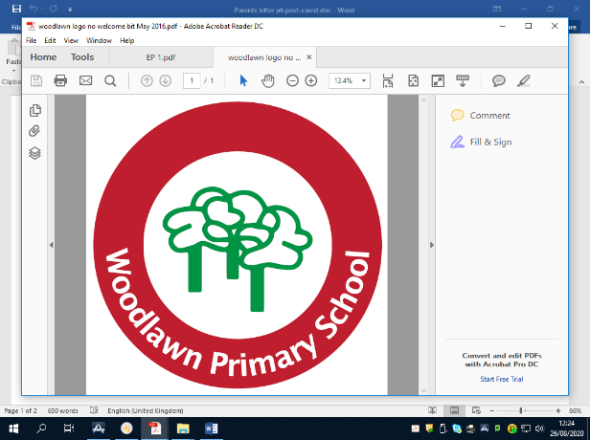

**P6**

**2021-2022**

**Welcome to P6!**

**School start time: 8:50am**

**School finish time: 3:00pm**

**Please arrive at school and leave school by the car park gate**



**Healthy Break**

We have a healthy break Monday – Friday. Please ensure your child has a healthy snack with them each day to earn an ‘apple’ token. Please also note that **we are a completely nut free school.**

**Returning to school**

This year, returning to school may feel more than a little strange for you and your child. Please talk to your child about any worries they have and get in touch of there is anything that I can help with.

I will be encouraging children to talk about their worries and concerns as well as celebrating their strengths and achievements. Above all else, their mental health needs looked after.

**Keeping safe**

Encourage your child to wash their hands before they leave the house and when they come home. We will be washing and sanitising hands throughout the school day.

Please make sure your child has their own tissues and hand sanitiser which will be kept at their desk.

There are signs throughout school reminding children to keep hands clean, stay apart from others and to walk on the left-hand side of corridors.

*Always remember to cross the road with Sandra!*

**Classwork**

Work in school is expected to be neat, tidy and completed on time. For class your child will need:

* Pencils
* Rubber
* Blue/red pen
* Ruler
* Highlighter

**Homework schedule**

|  |  |  |  |
| --- | --- | --- | --- |
| Monday | Tuesday | Wednesday | Thursday |
| Spellings  Write first set 3 times  Literacy written homework | Spellings  Write second set 3 times  Numeracy written homework | Spellings  Write third set 3 times  Literacy written homework | Spellings  Revise all spellings  Numeracy written homework |
| Reading will be sent home in a large chunk once a week. Please split the reading into smaller, more manageable pieces to read throughout the week. Your child should write a comment about what they have read to share with their reading group on their reading day (1 comment per week). Check reading records and sign weekly. **Friday Test book will be sent home on a Friday. Please sign and return on Monday or Tuesday.** | | | |
| Mental maths – mental maths will be set on a Monday to be learnt for Friday check-up. We are aiming for quick and accurate recall of times table facts. Tables will range each week and could involve revision or work being covered in class. | | | |

**Spellings**

New spellings are set on Monday, Tuesday and Wednesday. Revise these on a Thursday night for a Friday test. These spellings should be written out neatly, three times each night. I would ask for your support in helping your child with their spellings and their meanings, A useful aid in learning spellings is the ‘Look, Say, Cover, Write and Check’ method.

There will be no homework set over the weekend although your child should be encouraged to read his/her own book. If ***any*** homework set is found to be too difficult, please send a message on Seesaw so I can help your child to overcome any problems.

Lastly, I am so excited to be your child’s class teacher and I can’t wait to see them grow and develop this year.

Miss Montgomery.

